# Results

After completing all the design and integration phases following the V-model (appendix 7.1-7.7), a complete overview of the system is created. This contains all the variables, properties and formulas to use as a guideline while developing a simulation of the propulsion system of the Solar Boat.

The project basically had three phases apart from the V-model. During the first part of the project research has been done about propulsion systems and calculations based on that. This is all shown in the V-model “component design” (appendix 7.4). Using all the information and separate calculations, the simulation is build up. This is done with the help of the V-model “integration” (appendix 7.5-7.7). The last step is to simulate and validate the current propulsion system of the Solar Boat, Sealander. For that all the components have been checked and the corresponding properties are inserted in the system.

## Designing

The complete design of the simulation can be depicted in a flowchart containing all the different components and order of calculations. This flowchart is shown below. The arrows give the direction of the data flow. This is used for coupling the calculations into a calculation chain. Different values for different components can be calculated with formulas retrieved from physics.

Each calculation has basically three types of values. The first ones are the variables that are inserted, coming from the user or the previous calculation. The second set of values are the values transmitted back to the user-interface, so the user can read them. The third and last set of values are the values that will be transmitted on to the next component with the corresponding calculations.

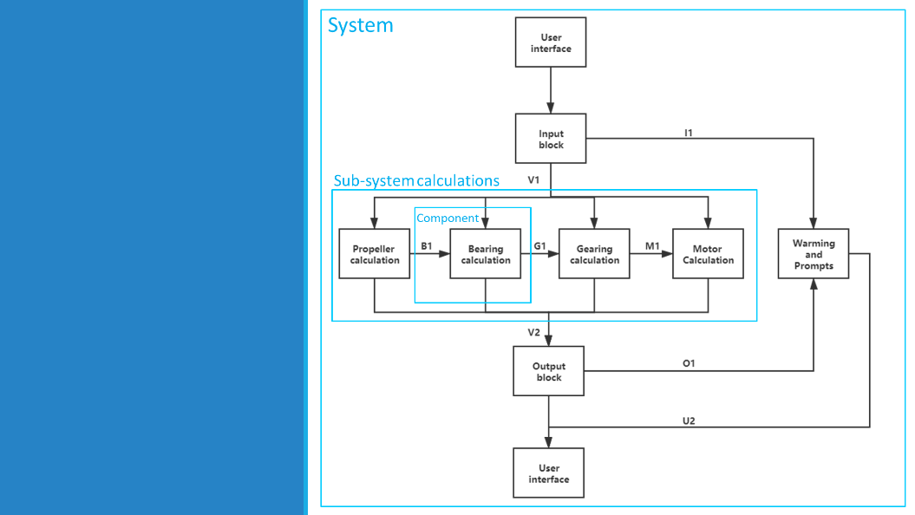

## Integrating

After this is all set up individually, the links are being connected into a calculation chain. To interact with the user, a user-interface is designed. This is a user friendly front panel where only the relevant values are being shown. Therefore the user does not need any technical knowledge to use the simulation. Some relevant values are used to give more insight into the performance of the propulsion system. An example of this are the energy outputs and accompanying graph displayed at the bottom.

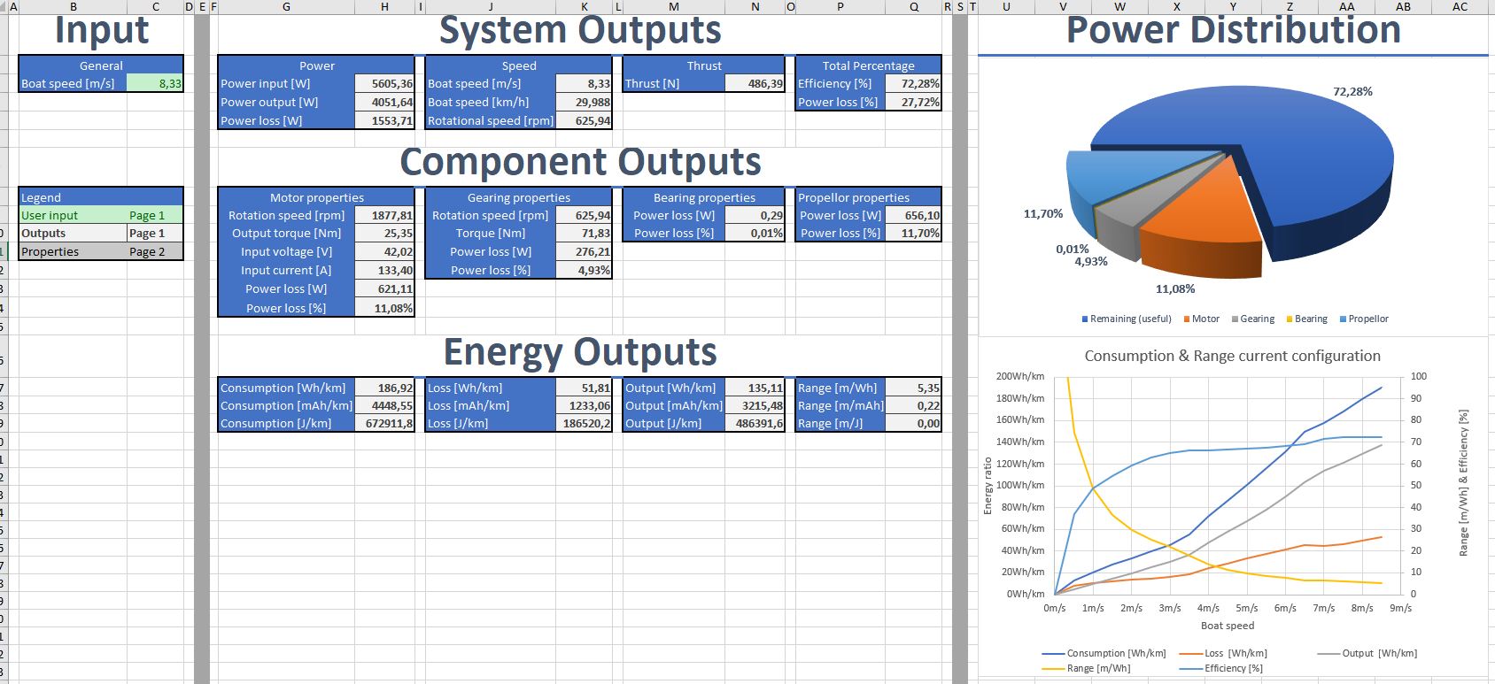

## Simulating

The last step is simulating the current propulsion system and making a digital twin. The properties of the components used in the current propulsion system can be found in the corresponding datasheets. It has also been verified that the datasheets attached belong to the components. There are 4 main physical components; The motor, the transmission (gearing), the bearings, and the propellor.

Verifying the motor was relatively easy, which has been done by comparing the motor nameplates. Attached with the main datasheet were extensive curves showing the load and rotational speed behaviour at different voltages. This dataset was used and expanded using linear inter- and extrapolation. This could be done because the rpm-voltage and rpm-load behaviour is almost linear with a DC motor. This makes swapping the motor easy if the same data array is provided.

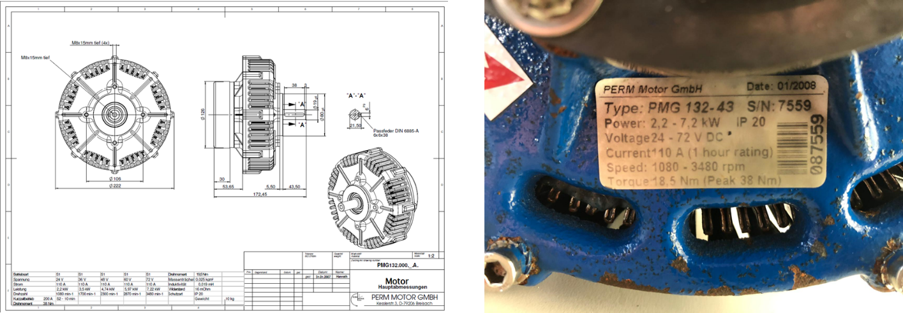

The gearing is verified by opening up the strut, counting teeth and measuring the diameters. All other properties are either from the datasheet, or using generic standard values. This allows for extensive customizing of the gearing system.

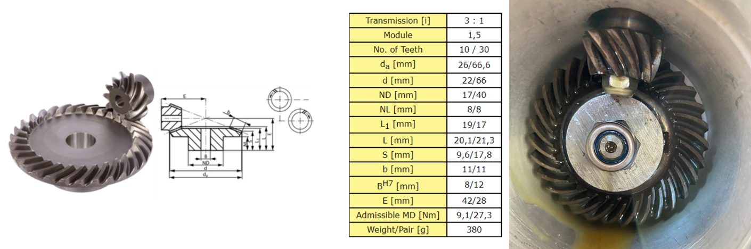

The bearings used in the propulsion system were confirmed by using SolidWorks drawings of the strut. Combined with generic friction coefficients belonging to different bearing types, and an estimation of the load on them, the bearing properties were selected.

The last component is the propellor. Since the propellor used is not labelled with a name or code, it was a little bit harder to verify this component. But by diving in to the SolidWorks drawings of the solarboat, information about the propellor was found. Using the diameter and shape, the propellor could be confirmed. Coupled with the propellor, a data array of different propellor properties varying by boat speed was provided.

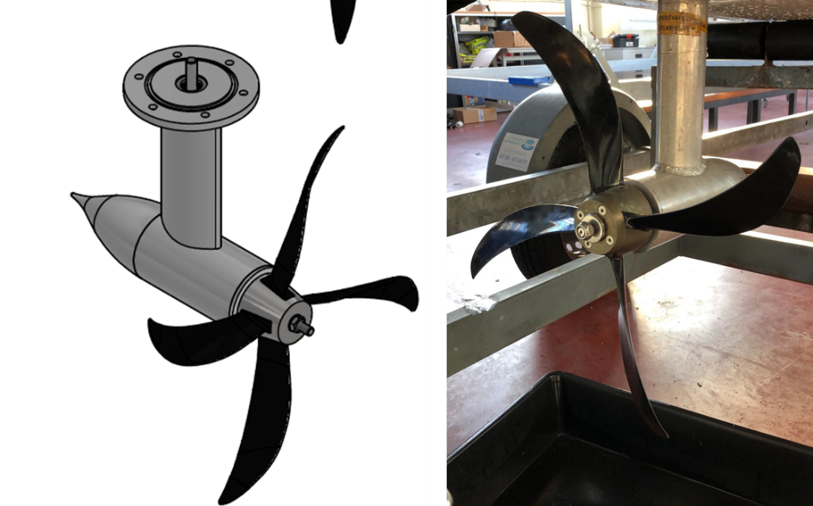

## Validating

Now that all the properties of the different components are determined and inserted into the simulation, calculations can be made. The simulation should be validated with its error margin being less then 10%. The MARIN did a lot of tests years ago and gathered empirical data. This data is stored in this file: *“propdesign_algemene_sheet marof v3 HZ pr”.* A project group from a previous year made calculations with this empirical data and stored them in the same file, under the page: “*propulsion ENG”.* This sheet has some of the same outputs as the simulation so they can be compared and a deviation can be calculated based on that. On the table below is shown how the simulated in-/output power and thrust deviates from the MARIN sheet for different boat speeds. Since none of the deviation is more than 10%, there can be stated that this simulation is valid and very accurate.

